ShopNest (NexusGoods) E‑Commerce Dashboard —Analytical Report

1. Introduction
This report presents a comprehensive business intelligence analysis of the Nexus Goods e‑commerce dataset developed using Power BI. The objective was to design a single‑sheet interactive dashboard delivering insights across sales performance, delivery efficiency, customer behavior, product satisfaction, and seasonal trends.

2. Data Model Overview
A star schema model was implemented.
Fact Tables:
• Orders
• Order Items
• Order Payments
• Order Reviews
Dimension Tables:
• Customers
• Products
• Sellers
• Category Translation
• Date Table
Revenue was calculated at the order‑item level including freight charges.

3. KPI Summary
Key performance indicators were placed in the top banner of the dashboard to provide an executive snapshot.
KPIs Included:
• Total Revenue — Sum of product price and freight value
• Delayed Orders — Orders delivered after estimated date
• Average Rating — Mean customer review score
These KPIs enable rapid evaluation of business performance, operational efficiency, and customer satisfaction.

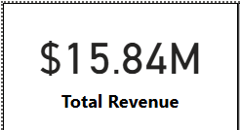

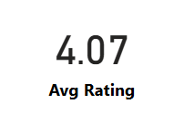

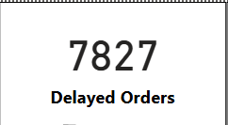

4. Q1 — Top 10 Categories by Total Sales
Technology and electronics categories generate the highest revenue. Furniture contributes significant freight‑driven sales. Revenue concentration indicates demand skew toward key product segments.
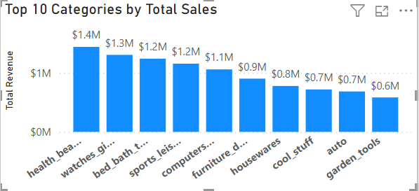

5. Q2 — Delayed Orders by Category
Higher delivery delays are observed in bulky product categories due to logistics complexity,
handling requirements, and shipping distances.

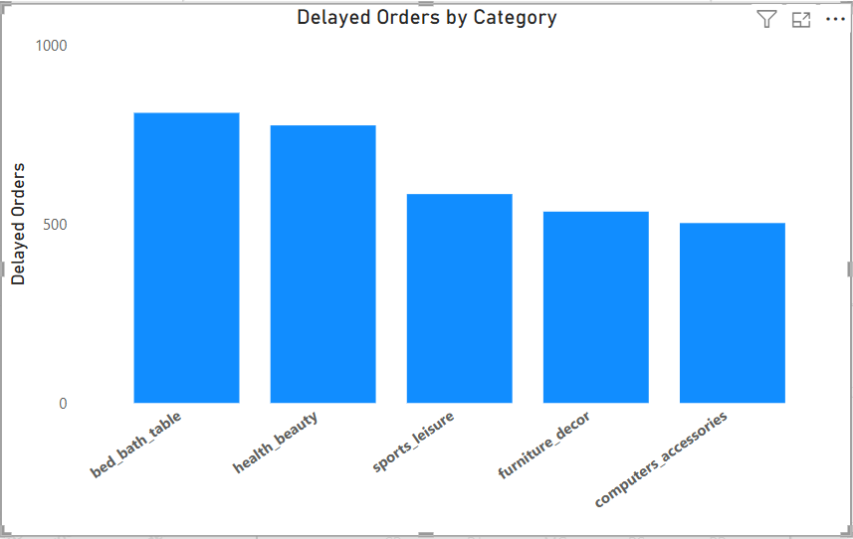

6. Q3 — Monthly Delayed vs On‑Time Orders
Delay spikes align with peak sales months, indicating operational strain during high‑volume periods.
On‑time performance improves during off‑peak months.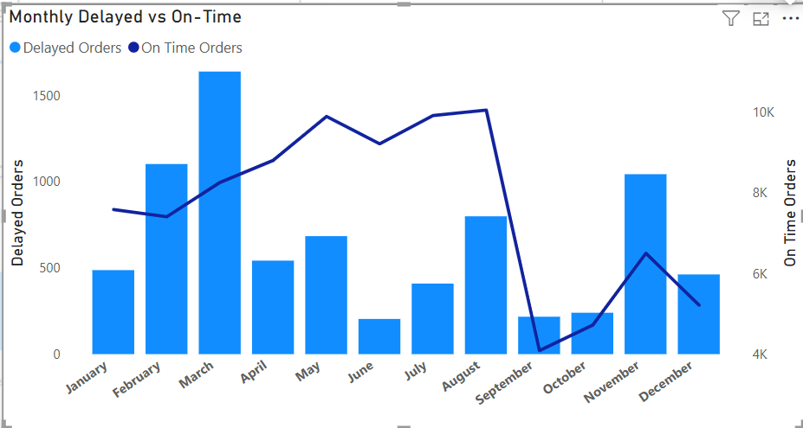
7. Q4 — Payment Method Analysis
Credit cards dominate transactions. Digital wallets show growing adoption, while installment payments are common for high‑value purchases.
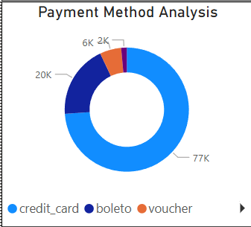

8. Q5 — Product Rating Analysis (Top & Bottom 10)
Reviews are captured at order level rather than product level, meaning all products within an order inherit the same rating.

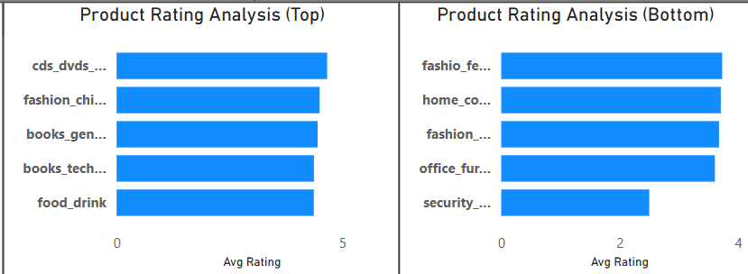

9. Q6 — State‑Wise Sales
Urban states contribute the majority of revenue, while emerging regions demonstrate growth potential.
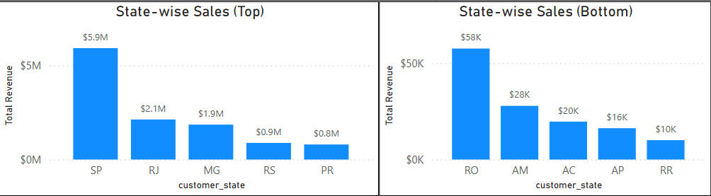

10. Q7 — Seasonal Sales Patterns
Quarterly analysis shows Q4 peak demand driven by holiday shopping followed by Q1 slowdown.

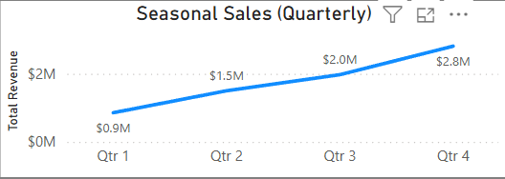

11. Q8 — Yearly Revenue Trend
Year‑on‑year growth indicates expanding business performance supported by rising order volumes.
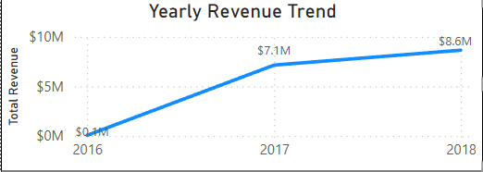

12. Dashboard Design
A single‑sheet dashboard integrates KPIs, category performance, delivery metrics, payment analysis, geographic sales, and time‑intelligence visuals with interactive slicers.

13. Conclusion
The dashboard delivers a unified analytical view enabling stakeholders to make informed strategic,
operational, and customer‑experience decisions while identifying growth opportunities.

